<https://www.javatpoint.com/hibernate-tutorial>

JPA - Java Persistance API

Persistance - Serialization in a RDBMS file

JPA - persistance.xml

JPA is a specification

Serialization - This is process of storing the state of an object to a permanent storage(flat file -- .txt, .rtf, .doc)

Employee {

id

name

salary

}

emp = new Employee(100,"Abc", 25000);

emp1 = new Employee(101,"Xyz", 20000);

Deserialization - Is the reverse of Serialization

(Constructing the object from the serialized data)

Marker Interface - Serializable

(An interface with no methods)

//specification

interface Shape {

public void area();

}

//implementation of Shape interface

public class Circle implements Shape {

public void area() {

//area method implementation

}

}

JPA Implementation

1) Eclipse Link

2) Hibernate (Popular)

3) iBatis

CRUD - Create Read Update Delete (DB Operations)

JDBC - Java Database Connectivity

1) Load & Register Driver [class.ForName()]

2) Establish the connection [connection(I)]

3) Create & Execute the Query [statement/ p.stmt/c.stmt(I)]

4) Process the result [resultset]

5) Close all the resources

JPA - Connect to the DB using GUI-

Eclipse EE Edition - <https://www.eclipse.org/downloads/packages/>

Eclipse Link 2.5.2 - <https://www.eclipse.org/eclipselink/releases/2.5.php>

MySQL Driver zip - <https://dev.mysql.com/downloads/connector/j/>

MySQL Workbench - <https://dev.mysql.com/downloads/workbench/>

Step 1) Open Eclipse EE

Step 2) File ->New -> others -> JPA Project

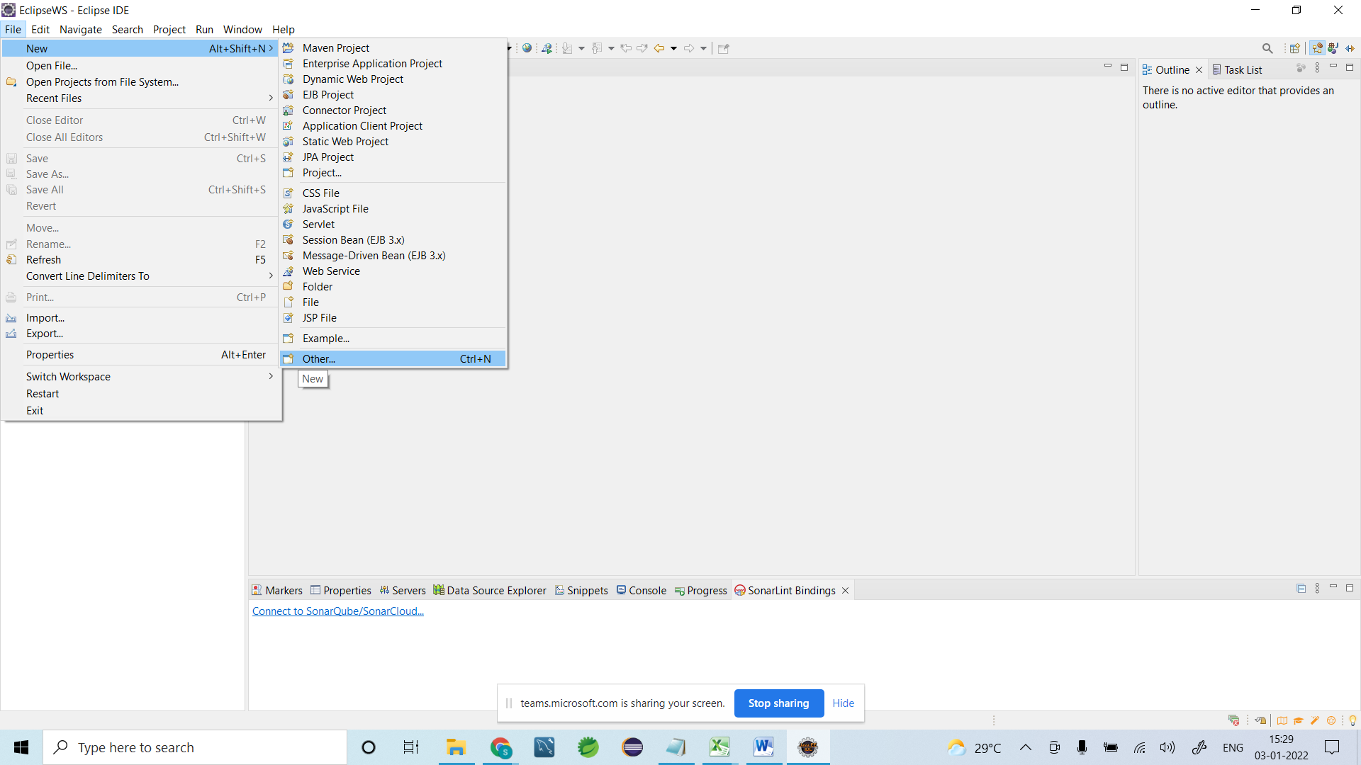

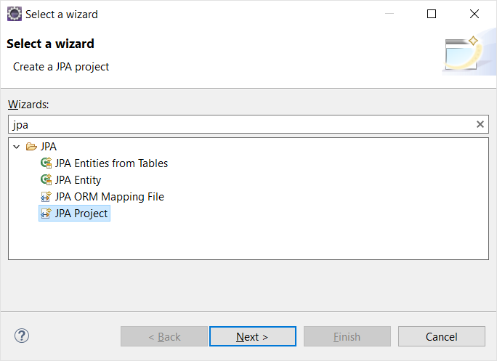

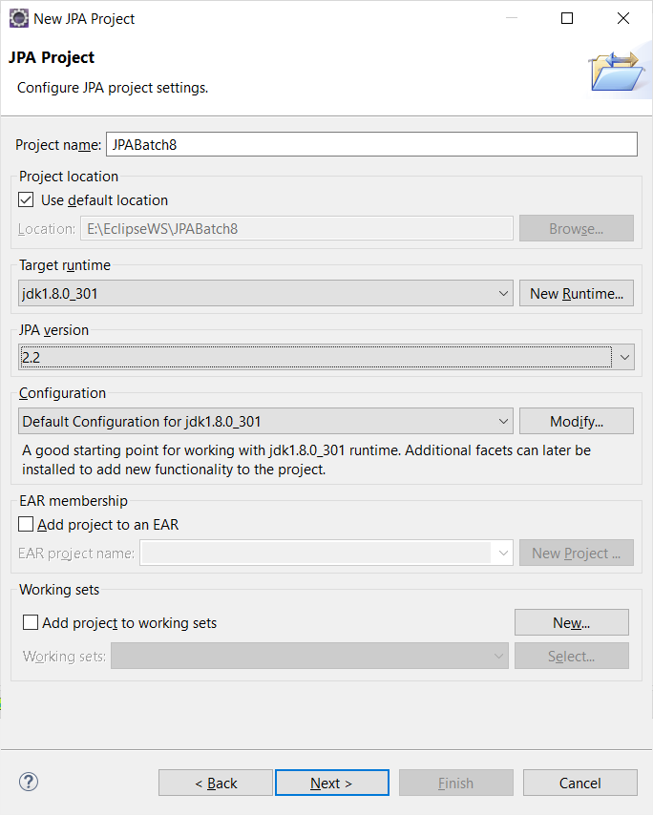

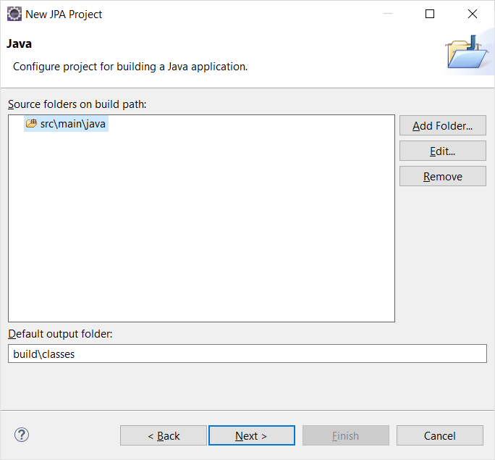

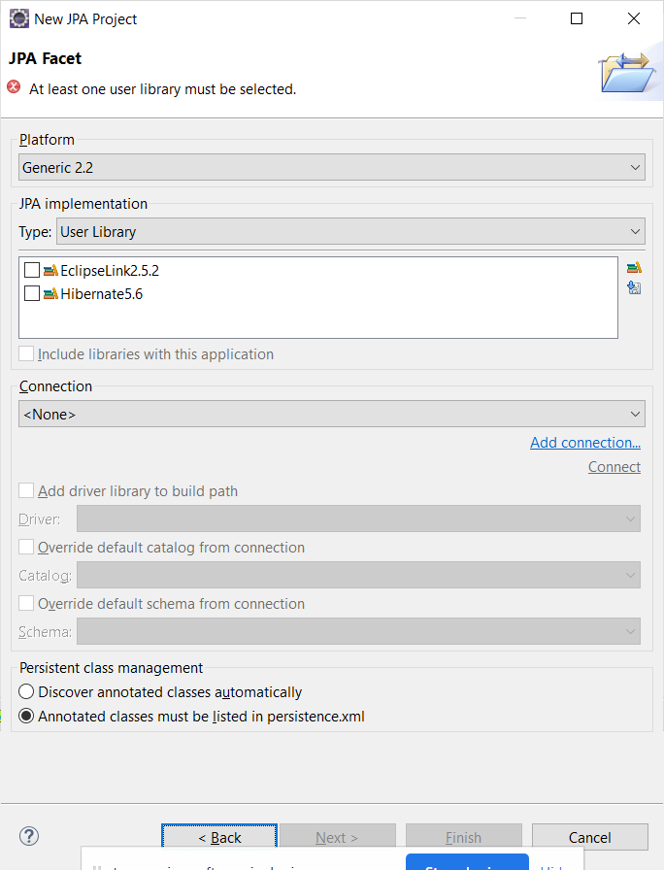

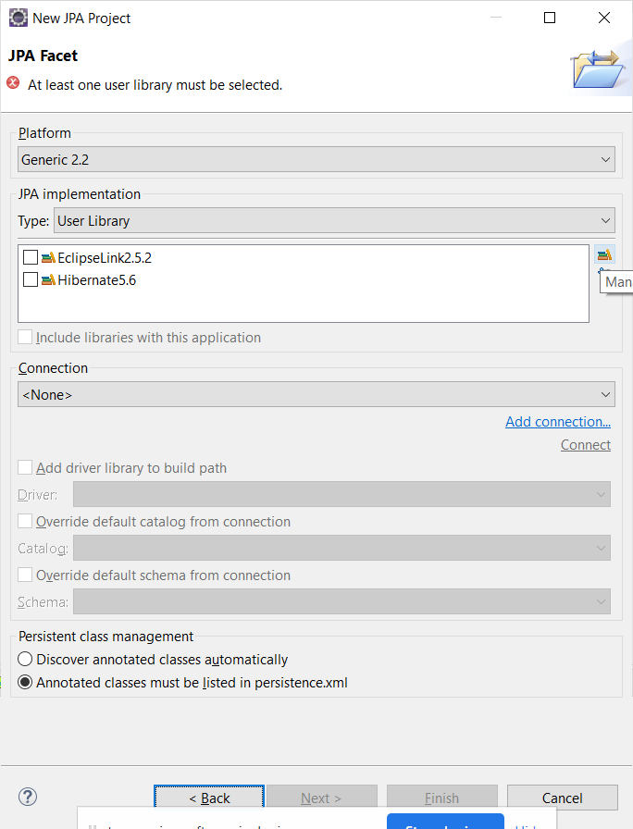

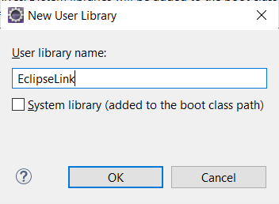

<extracted_location>\eclipselink-2.5.2.v2014\eclipselink\jlib – eclipselink.jar

